Mississippi State University

Group Project Part 3

Web-based Course Waiting List Maintainer: Designing/Using Database

Prepared by Group 8

CSE 4503/6503 Database Management Systems

Dr. Leann Markham

Due Date: 11/ 30/ 2021

**1.**

**1. What classrooms are available across all of the campus? The result should be sorted in**

**decreasing order of room size. List the building name, room number, and capacity of**

**each room.**

SELECT ROOM, BUILDING, CAPACITY

FROM LOCATION

ORDER BY CAPACITY DESC;

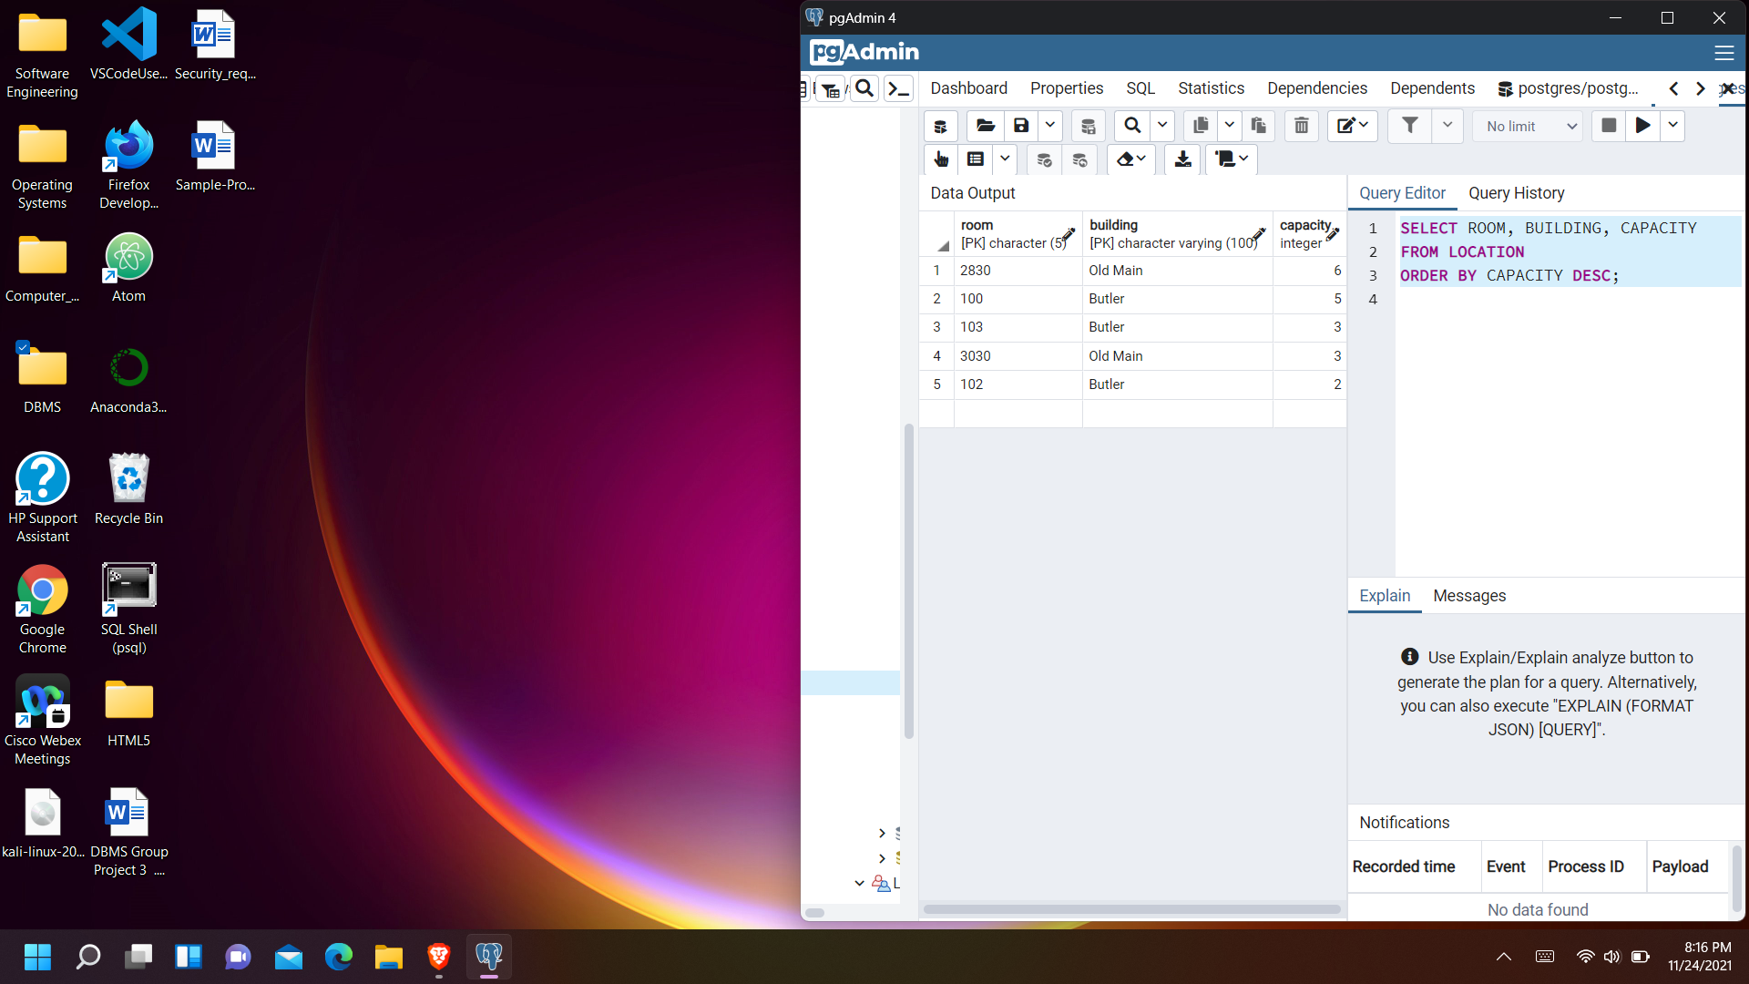

**2. Which courses are required for both Computer Science curriculums? Use intersect in**

**your query. List the symbol and number for each of the courses in the results.**

SELECT symbol, number

FROM course, curriculum

WHERE major = 'Computer Science' AND year = '2014'

INTERSECT

SELECT symbol, number

FROM course, curriculum

WHERE major = 'Computer Science' AND year = '2017’

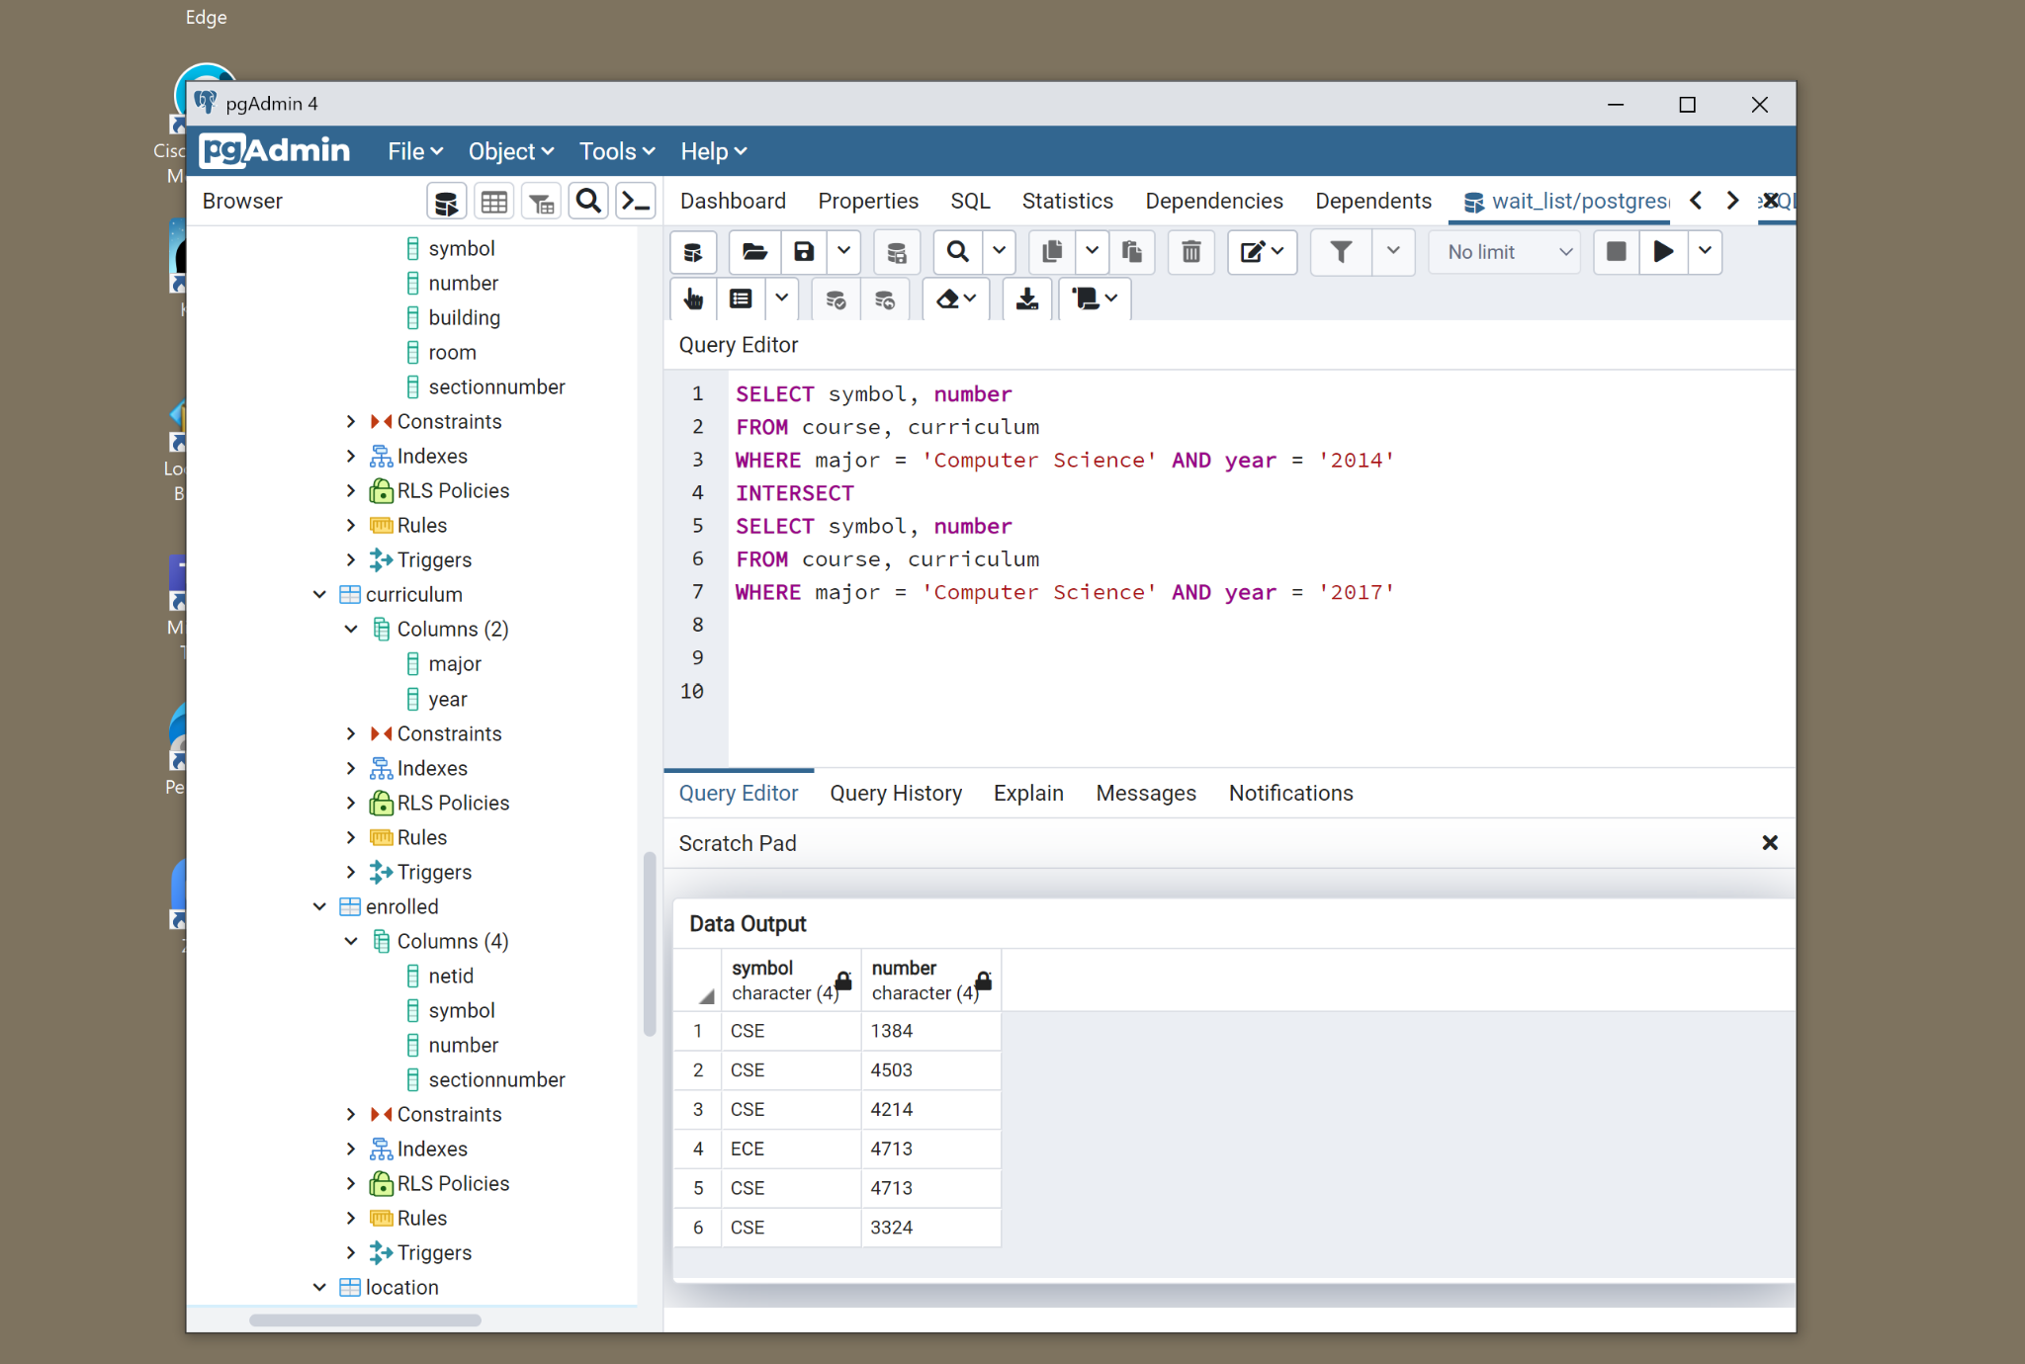

**3. Which students are majoring in Computer Science? For each student in the results, list**

**their name, netid, and classification.**

SELECT s.firstname, s.lastname, s.class, s.netid, c.netid

FROM student as s, choose as c

WHERE s.netid = c.netid and c.major= 'Computer Science';

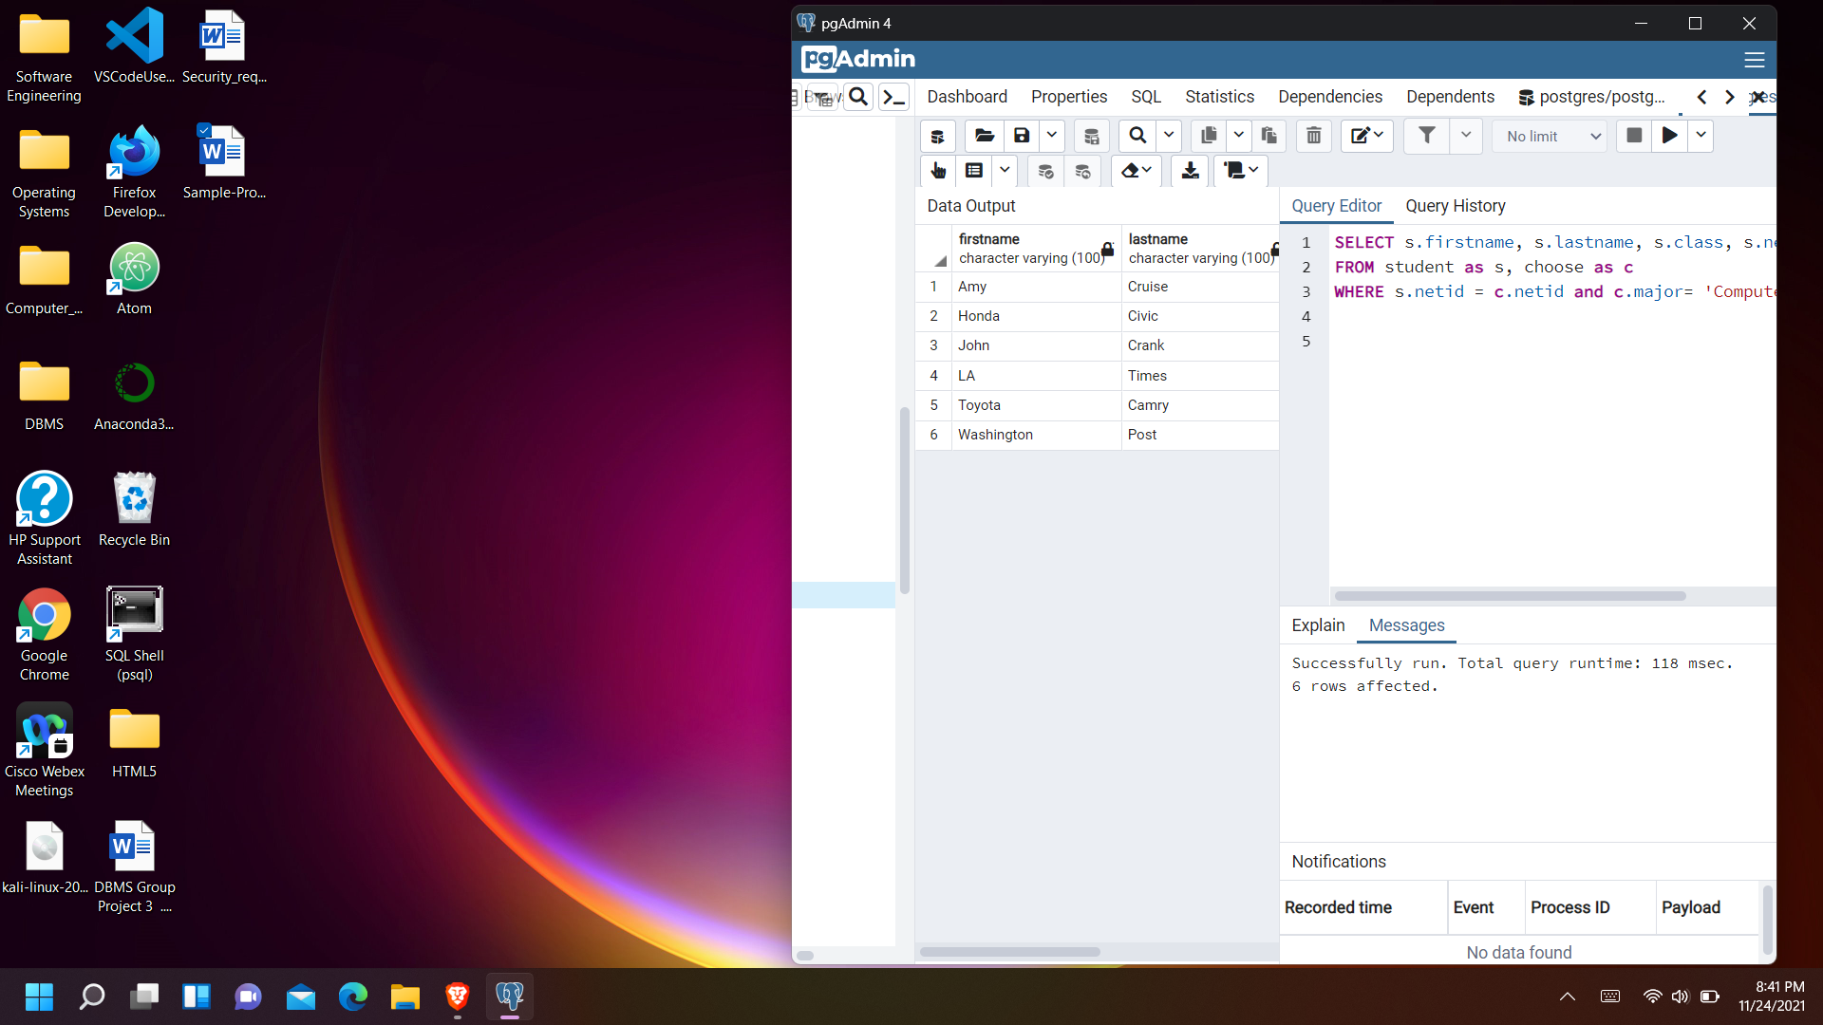

**4. Which students are graduating seniors? Order the results by student last name. For each**

**student in the results, list their netid, first name, last name, and major.**

SELECT DISTINCT s.netid, s.firstname, s.lastname, c.major

FROM student s, choose c

WHERE s.graduating = '1' AND s.class = 'senior' AND s.netid = c.netid

ORDER BY lastname

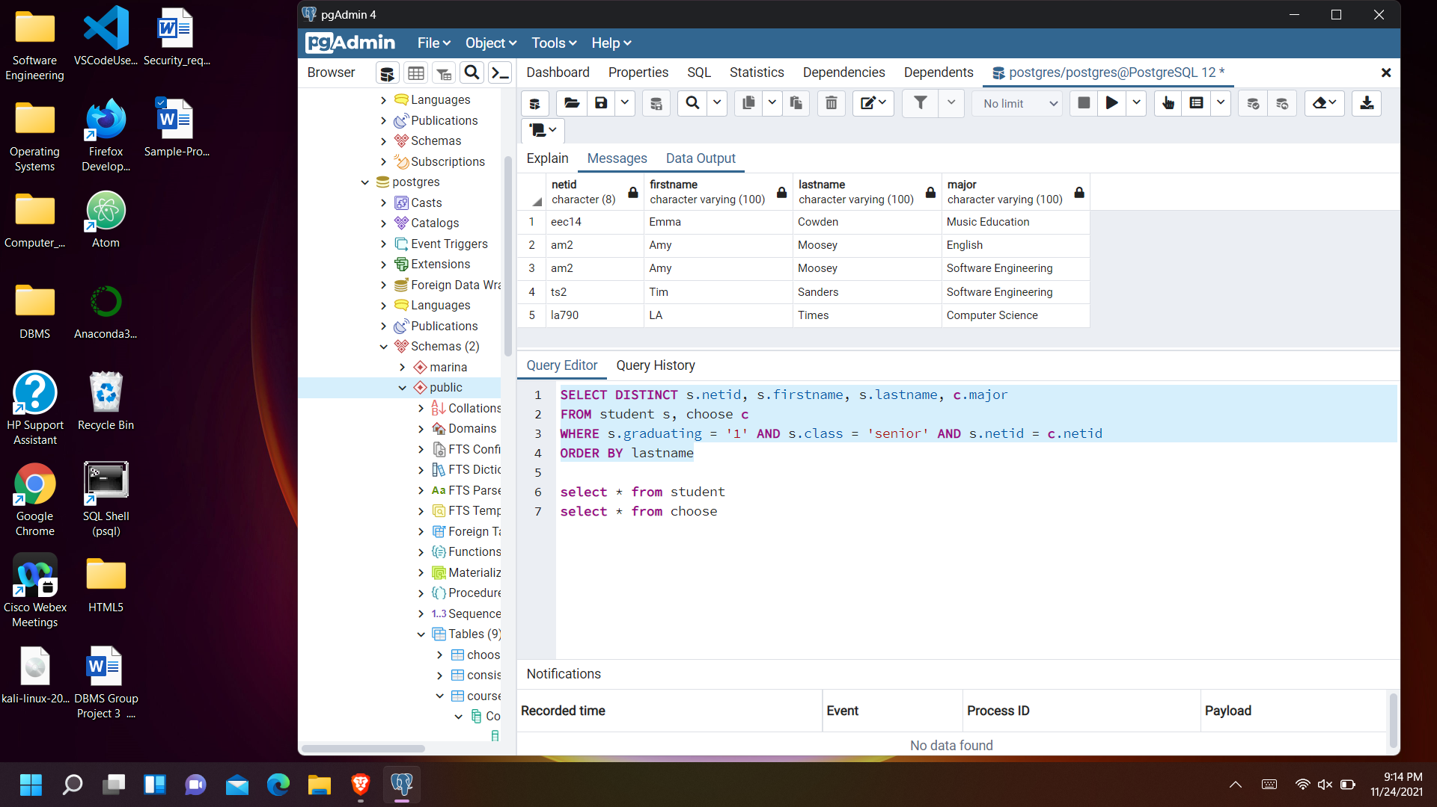

**5. Which course offerings are currently full (the number of students enrolled equals the**

**capacity of the room it is held in)? For each of the course offerings in the results, list its**

**symbol, number, section number, building, room number, and capacity.**

select c.symbol, c.number, c.sectionnumber, c.building, c.room, l.capacity

from ((courseoffering_of AS c JOIN location AS l ON c.building = l.building AND c.room = l.room)

JOIN enrolled AS e ON c.symbol = e.symbol

AND c.number = e.number AND c.sectionnumber = e.sectionnumber)

GROUP BY c.symbol, c.number, c.sectionnumber, c.building, c.room, l.capacity

HAVING COUNT(netid) = l.capacity;

Alternatively,

select e.symbol, e.number, e.sectionnumber, l.building, l.room, l.capacity

from enrolled As e, location As l

GROUP BY e.symbol, e.number, e.sectionnumber, l.building, l.room, l.capacity

HAVING COUNT(netid) = l.capacity;

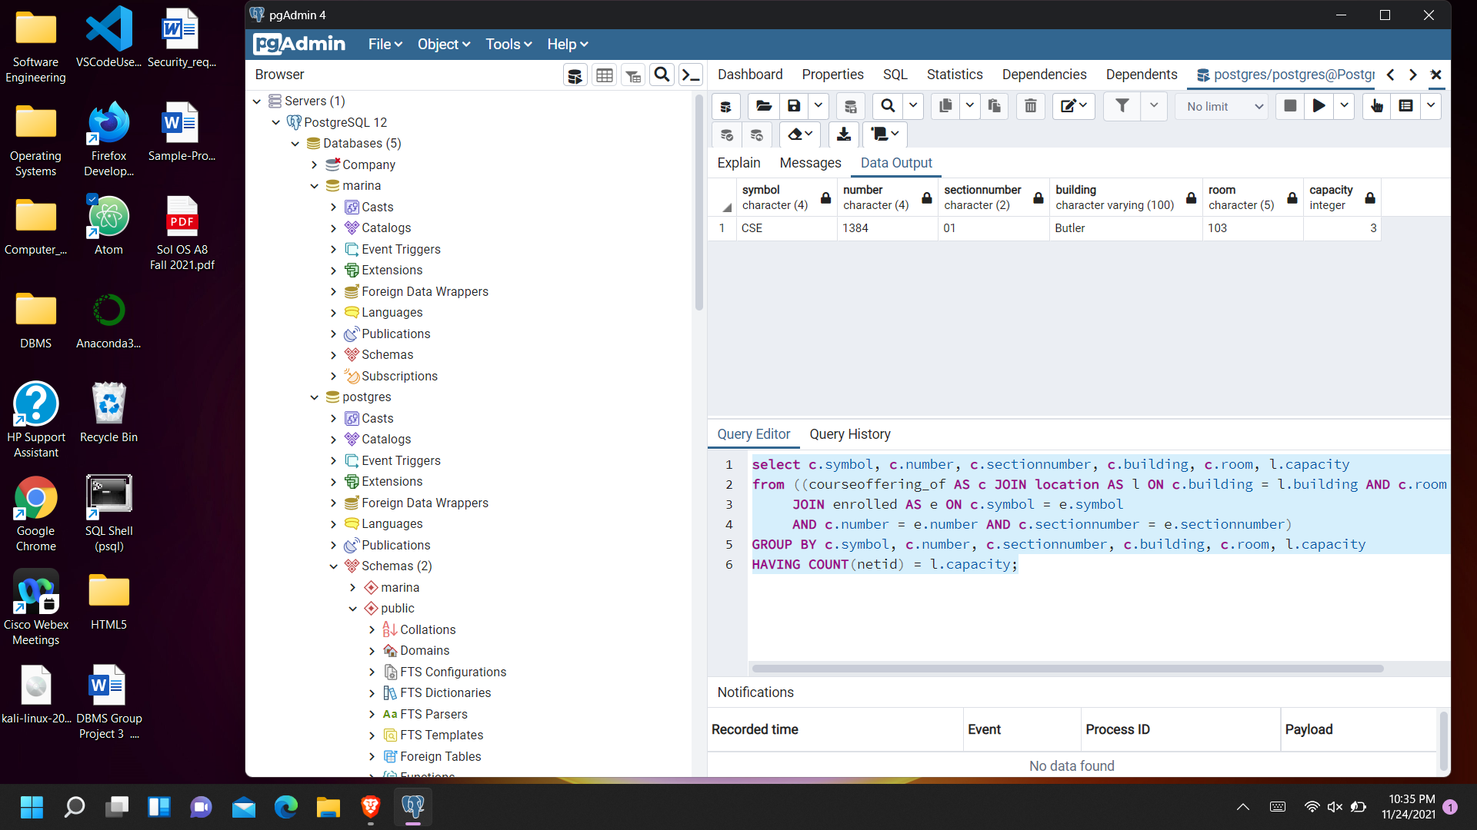

**6. Which students are enrolled in CSE 4503 01? List the results in order of student last**

**name. For each student, list their netid, first name, last name, and major.**

SELECT a.netid, a.firstname, a.lastname, major

FROM student a, enrolled b, choose c

WHERE a.netid = c.netid AND symbol='CSE' AND number='4503' AND sectionnumber ='01' AND a.netid = b.netid

ORDER BY a.lastname

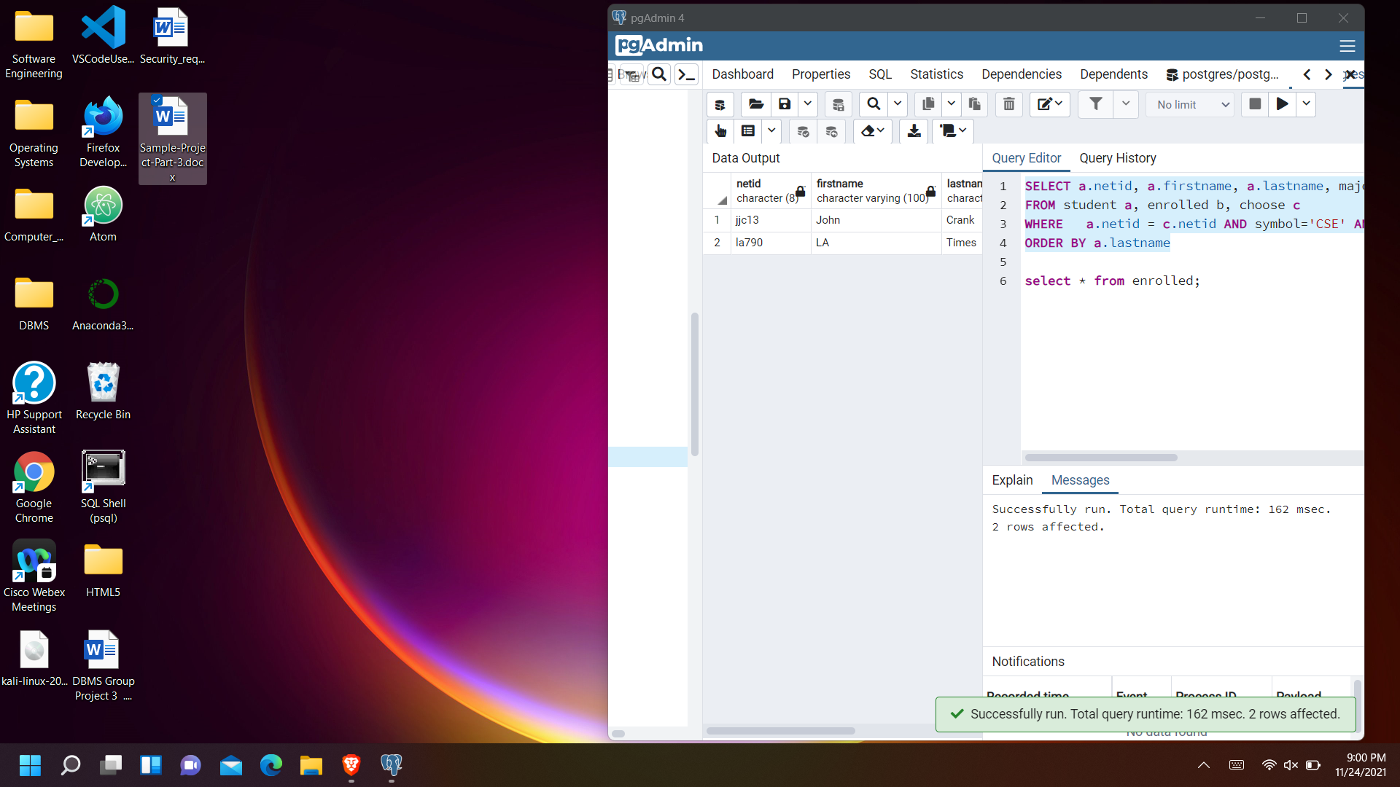

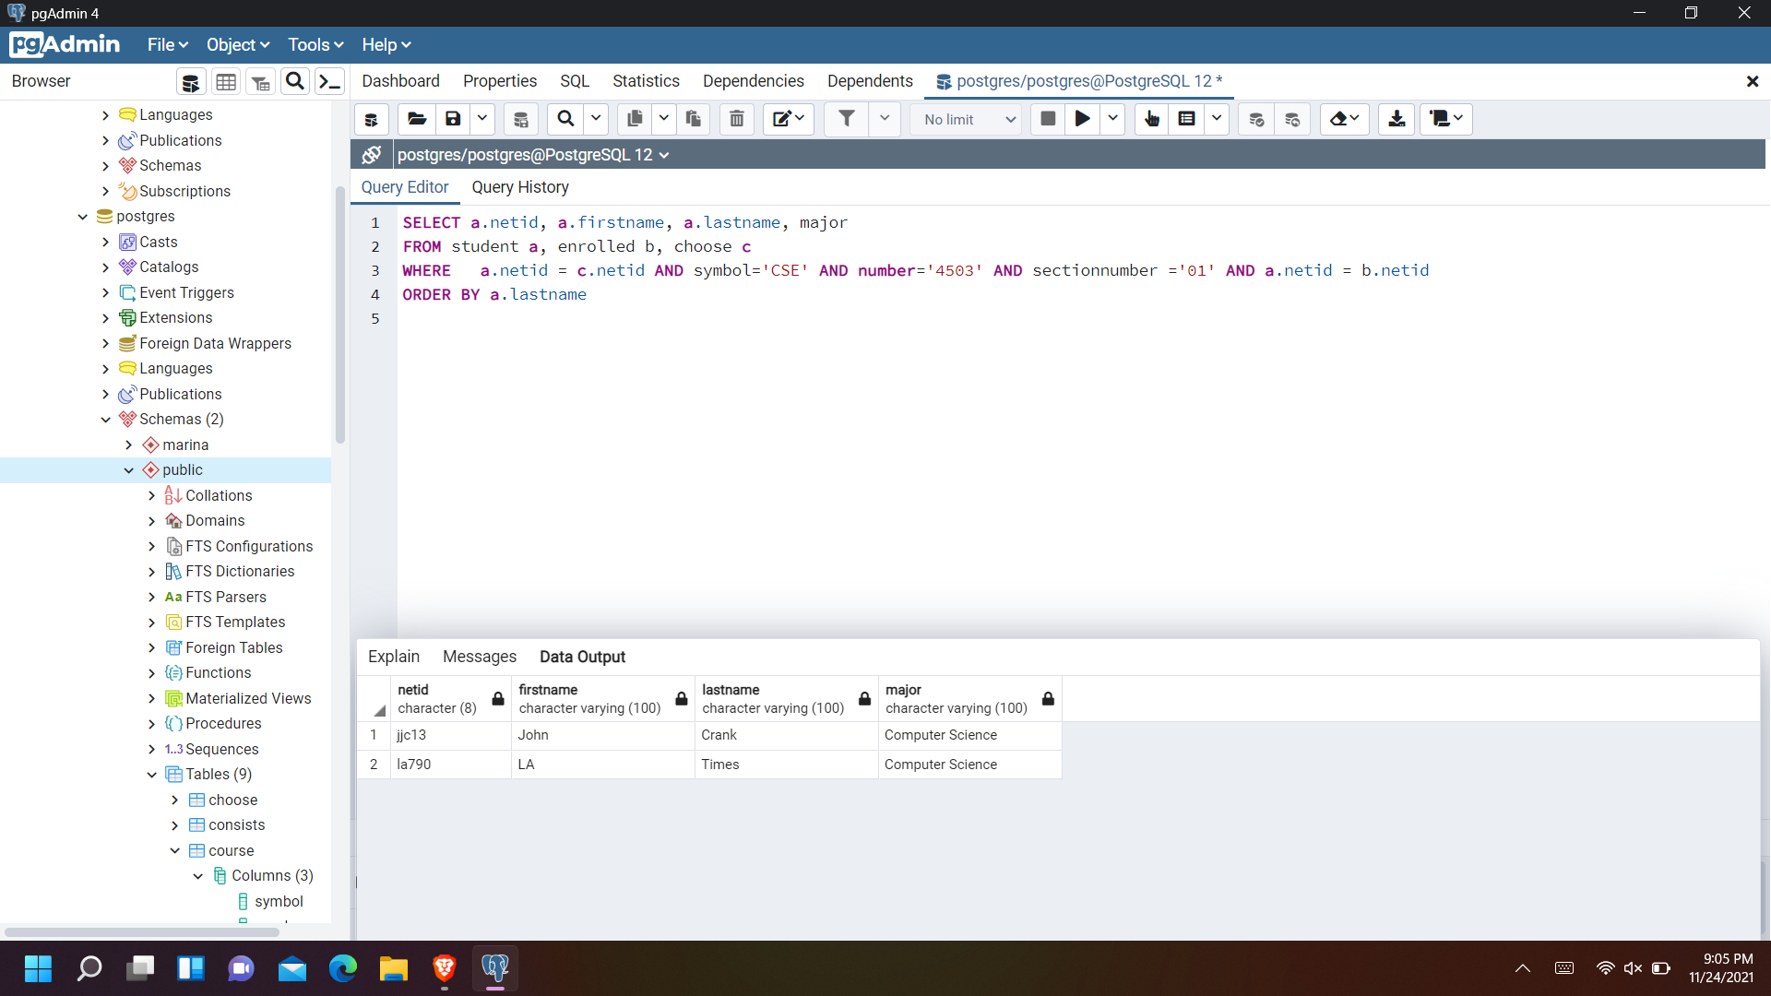

**7. Are there any students that are on both the enrolled list and waiting list for the same**

**course section? If so, list their netid and the course (course symbol, number, and section**

**number).**

select e.netid, e.symbol, e.number, e.sectionnumber

from enrolled e, waitinglist w

where e.netid = w.netid AND e.symbol = w.symbol AND e.number = w.number

AND e.sectionnumber= w.sectionnumber;

Alternatively,

SELECT e.netid, e.symbol, e.number, e.sectionnumber

FROM enrolled AS e JOIN waitinglist AS w ON e.netid = w.netid

WHERE e.symbol = w.symbol AND e.number = w.number AND e.sectionnumber = w.sectionNumber;

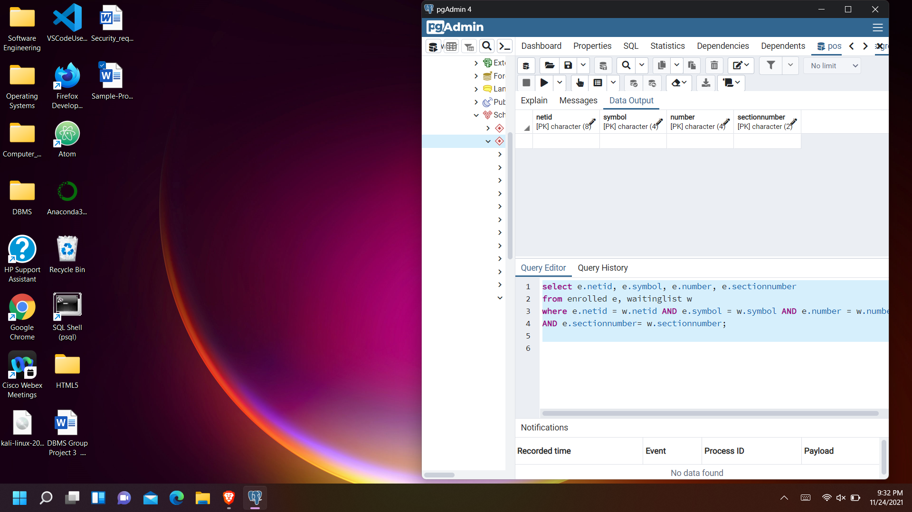

**8. Who are the graduating seniors on the waiting list of CSE 4503 01? For each student, list**

**their netid, last name, first name, and date/time added to the waiting list. Order the list in**

**decreasing order of how long the student has been on the waiting list.**

SELECT s.netid, s.lastname, s.firstname, w.since

FROM (student AS s JOIN waitinglist AS w ON s.netid = w.netid)

WHERE w.symbol = 'CSE' AND w.number = '4503' AND s.graduating = '1' ORDER BY since DESC;

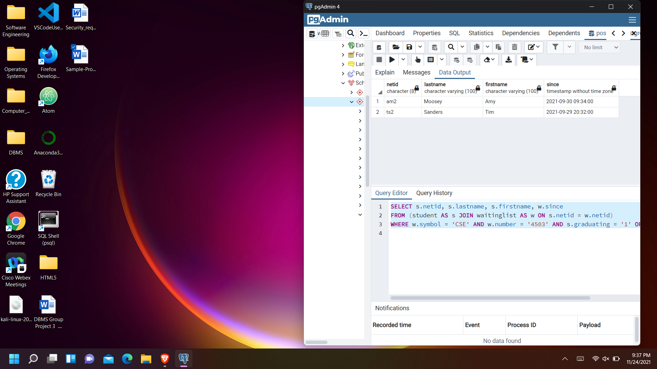

**Refere**nces

Markham, Leann. (2021). wait_list.sql.txt*.* DBMS.

Kantarcioglu, Murat (n/d). “SQL Examples”, UTD.

https://personal.utdallas.edu/~muratk/courses/db17files/sql-examples.pdf